We know getting approval for Conference Attendance can be a difficult process, so we’ve put together some details we think might make it easier to “sell” attending IPAC in 2016.
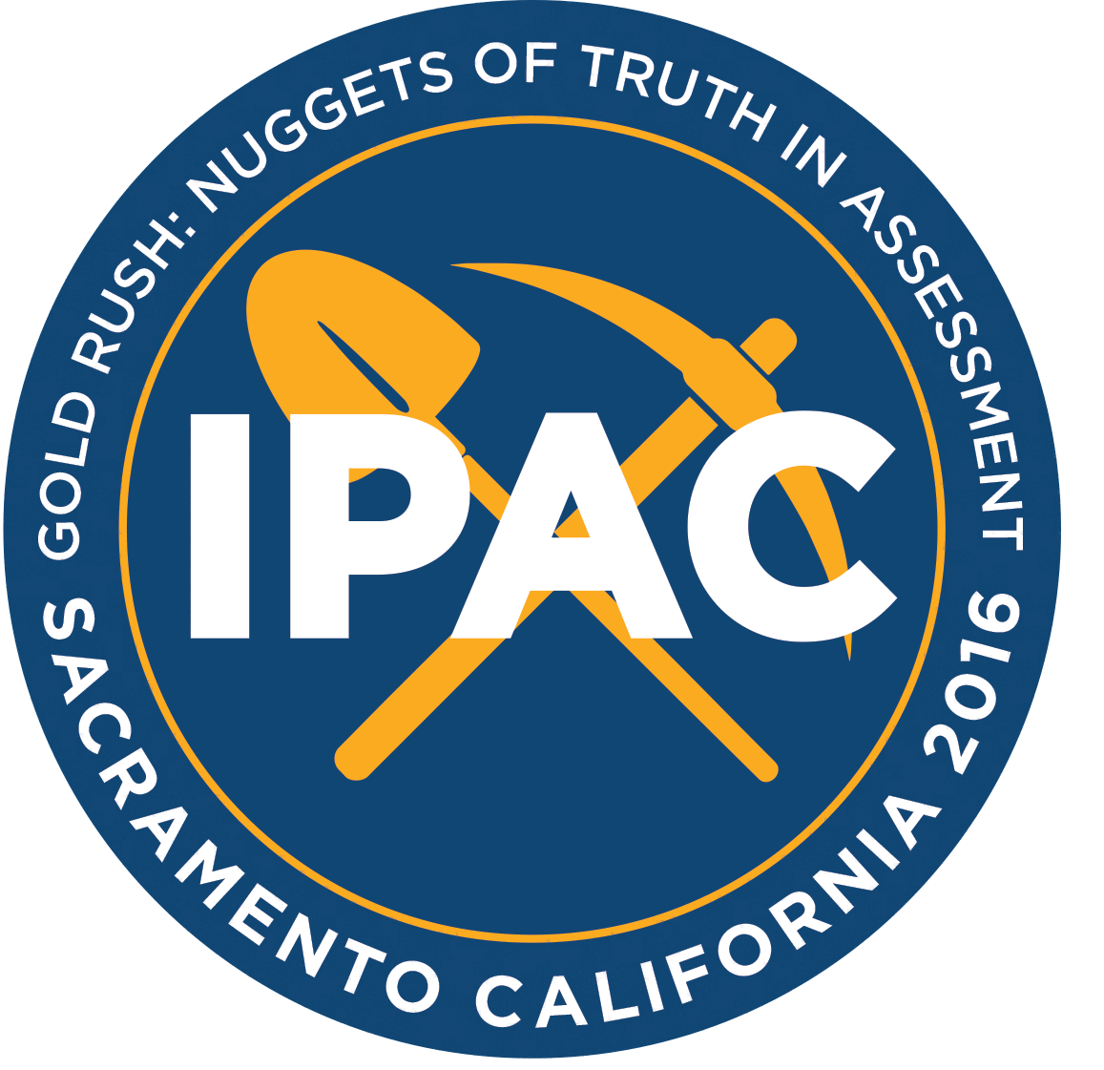
NOTE: Remember everything is cheaper if you are a member!
HOTEL 2016 Hotel Cost - $112 per night
Keynote Speakers:
- Dan Putka; HumRRO
- Harry Brull; BCG Consulting Group
- Deniz Ones; University of Minnesota
- Ryan Ross; Hogan Assessments
- Greg Hurtz; California State University: Sacramento
2016 conference pricing
 | Early | Regular | Late
Member | $325 | $375 | $400
Non-member | $400 | $450 | $475
Student | $100 | $150 | $175

Half Day Workshop Pricing
 | Early
Member | $100
Non-member | $150
Student | $75

HRCI and SHRM Credits - Recertification credits are always in high demand, and IPAC always gets both the workshops and conference itself approved.
- 2015 Conference – 12.5 credits
- 2015 Half Day Workshop – 3.5 credits

