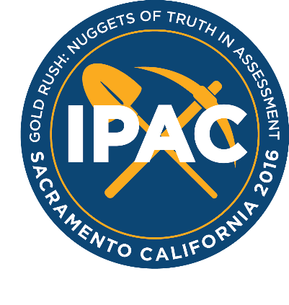
International Personnel Assessment Council
2016 Annual Conference, Sacramento

Conference: HRCI and SHRM Credits

Date: Monday, August 1, 2016 – Wednesday, August 3, 2016
Credit Hours: 12.5 HR (General)

HRCI Instructions

The 2016 IPAC Annual Conference has been approved for 12.5 HR (General) recertification credit towards the aPHR®, PHR®, PHRca®, SPHR®, GPHR®, PHRi® and SPHRi® recertification through the HR Certification Institute.

The activity ID number for the conference is 286011. Please be sure to note this activity ID number on your recertification application form. For more information about certification or recertification, please visit the HR Certification Institute website at www.hrci.org.

To print an approval certificate, do the following:
1. Log into the https://recert.hrci.org/account/login
2. Enter your Activity ID 286011in the filter
3. Change the Status filter from "Inbox" to "Completed Activities"
4. Click filter
5. Click the PDF icon to the right of your approved activity

SHRM Instructions

The 2016 IPAC Annual Conference has been approved for 12.5 recertification credits towards the SHRM-CP and SHRM-SCP recertification through the Society for Human Resource Management.

To access your approval certificate, search “IPAC” in the SHRM recertification portal and select the appropriate IPAC activity.

